 | Pimpri Chinchwad Education Trust’s  Pimpri Chinchwad College of Engineering Sector No. 26, Pradhikaran, Nigdi, Pune – 411 044
Distributed Computing Systems – Mini Project
Student Details -
Name: | Smit Sawarkar , Yash Somwanshi, Devashish Kaware
PRN: | 123B1F089, 123B1F094, 123B1F126
Division: | B
Title: | Distributed Multiplayer Game

1. Abstract

The Duel Arena system is a web-based, real-time, two-player competitive arena game designed to demonstrate foundational distributed computing principles, including server-authoritative state synchronization, client-side snapshot interpolation, deterministic race condition resolution, and event-driven WebSocket communication.

In traditional distributed game systems, permitting clients to calculate canonical coordinates or declare item claims introduces significant state divergence, desynchronization anomalies, and cheating vulnerabilities. Duel Arena eliminates these issues by employing a strict Authoritative Client-Server Architecture. Clients capture directional intent via keyboard inputs (WASD and Arrow keys) and dispatch sequence-numbered input packets to the server. The server runs a fixed 30 Hz physics simulation loop, enforces arena boundaries, normalizes velocity vectors, evaluates coin collection collisions atomically, maintains authoritative match timing (120 seconds) and scoring, and broadcasts world state snapshots to connected clients at 20 Hz. Clients reconstruct fluid 60 FPS motion across variable network latencies using a 100 ms snapshot interpolation buffer.

The system incorporates robust room lifecycle management (WAITING, COUNTDOWN, PLAYING, FINISHED, RESETTING, ABANDONED) and an isolated, development-only dual-player testing mode protected by server-side production safeguards. The project serves as an educational demonstration of distributed state replication, conflict resolution, and fault-tolerant session handling.

2. Introduction

Modern distributed interactive applications—such as real-time collaborative editors, financial exchanges, and multiplayer games—depend on architectures where multiple remote clients interact concurrently with shared, mutable state. Unlike stateless request-response web services, real-time distributed systems must continuously synchronize continuous state across unreliable networks subject to variable latency, packet jitter, and disconnections.

A central engineering challenge is maintaining state consistency without trusting client-side computations. If clients directly broadcast their positions or score increments, malicious actors or network desynchronization can corrupt the global application state.Duel Arena was developed to explore and demonstrate solutions to these challenges in a compact, self-contained TypeScript monorepo. Two players join an isolated match room via unique 6-character room codes. Rather than calculating world physics locally, clients function as input samplers and presentation renderers. The central server owns the canonical world state, integrating physics, resolving simultaneous resource competition deterministically, and broadcasting authoritative state snapshots.

The project is an educational artifact intended for college-level Distributed Computing Systems evaluation, illustrating real-time network protocols, concurrency arbitration, and state replication.

3. Objectives

To implement a Server-Authoritative Architecture: Ensure the central Node.js server maintains the single source of truth for entity coordinates, boundaries, scoring, match clocks, and victory determination.

To decouple Client Intent from State Mutation: Restrict client network payloads strictly to directional input vectors (dx, dy, seq, timestamp), rejecting any client-claimed coordinates or scores.

To eliminate Lag Explosions via Delta Clamping: Enforce server-side simulation step clamping (dt≤100 msdt \le 100\text{ ms}dt≤100 ms) to prevent teleportation exploits and instability caused by event loop delays.

To resolve Resource Contention Deterministically: Design an atomic collision detection and tie-breaking mechanism that eliminates double-allocation race conditions during simultaneous coin pickups.

To mask Latency via Snapshot Interpolation: Implement a client-side circular snapshot buffer with linear interpolation (LERP) running 100 ms behind real-time to convert jittered 20 Hz server packets into smooth 60 FPS canvas rendering.

To implement a Distributed Finite State Machine: Enforce rigid match lifecycle phase transitions (WAITING →\rightarrow→ COUNTDOWN →\rightarrow→ PLAYING →\rightarrow→ FINISHED →\rightarrow→ RESETTING) with graceful handling of peer disconnections (ABANDONED).

To guarantee Type Safety across Network Boundaries: Structure the system as an npm monorepo with a shared contract package (@duel-arena/shared) ensuring end-to-end compile-time verification of DTOs and Socket.IO events.

To provide a Rigorous Automated Test Harness: Validate room management, physics integration, race condition handling, and security safeguards using automated unit and integration tests.

4. Theoretical Background

4.1 Distributed Systems and Real-Time State Consistency

A distributed system consists of autonomous computing nodes that communicate over a network to coordinate actions. In interactive distributed simulations, the primary challenge is achieving consistent views of rapidly changing state in the presence of non-deterministic network delays (Δtlatency​) and packet arrival variance (jitter).

Two primary consistency models exist:

Peer-to-Peer (Lockstep / Deterministic Consensus): Every node executes identical simulation code. Inputs are exchanged before advancing each frame. This model suffers severe latency degradation, as the entire simulation stalls to accommodate the slowest node.

Client-Server State Replication: A dedicated server advances the simulation independently and broadcasts authoritative state updates. This model isolates client latency, prevents local tampering, and provides a single total ordering of events.

4.2 Authoritative Server vs. Dumb Terminal Model

In an authoritative architecture, the client is neither fully autonomous nor a simple streaming terminal:

Client-Side Responsibilities: Input capture, local prediction for immediate responsiveness, and interpolation of received world states.

Server-Side Responsibilities: Input validation, speed normalization, collision detection, authoritative clock management, and snapshot broadcasting. Clients never send: "My character is at (450,300)(450, 300)(450,300) and I picked up Coin #3."
Clients only send: "At timestamp TTT, my directional input is (+1,0)(+1, 0)(+1,0)."

4.3 Snapshot Interpolation and Jitter Buffering

Because WebSocket packet arrival is non-deterministic, rendering entities immediately upon snapshot arrival produces visible stuttering and jitter.

Duel Arena implements Snapshot Interpolation (LERP). The client delays rendering by an interpolation offset (Trender=Tcurrent−100 msT_{\text{render}} = T_{\text{current}} - 100\text{ ms}Trender​=Tcurrent​−100 ms). The client locates the two snapshots bounding TrenderT_{\text{render}}Trender​ (S1S_1S1​ at T1T_1T1​, and S2S_2S2​ at T2T_2T2​) and calculates the intermediate entity position:
α=T2​−T1​Trender​−T1​​,α∈[0,1]
P⃗render=P⃗1+α⋅(P⃗2−P⃗1)
This transforms discrete 20 Hz network packets into continuous 60 FPS on-screen motion

4.4 Concurrency and Race Condition Resolution
When multiple concurrent nodes contend for a shared, finite resource (such as two players reaching a coin at the same simulation step), distributed systems face race conditions. Without arbitration, both players might receive credit (a double-allocation anomaly).
Duel Arena solves this within its authoritative simulation tick using Euclidean distance ranking with an explicit slot-order tie-breaker, followed by atomic resource deletion before score incrementation.

5. System Architecture

+------------------------------------+
| @duel-arena/shared |
| - Shared DTOs & Constants |
| - Event Contracts & Math Helpers |
+-----------------+------------------+
|
+-------------------------+-------------------------+
| (Workspace Dependency) | (Workspace Dependency)
v v
+-----------------------+ +-----------------------+
| @duel-arena/server | | @duel-arena/client |
| - Node.js / Express | | - Vite + Phaser 3 |
| - Socket.IO Server | <====== WebSocket ======> | - Socket.IO Client |
| - Authoritative Sim | (Socket.IO) | - Snapshot Buffer |
| - Room & Coin Mgr | | - Keyboard Handler |
+-----------------------+ +-----------------------+

5.1 Client-Server Topology
The system operates as an authoritative client-server system built with Node.js and Socket.IO. The server maintains room registries, validates payloads, runs simulation ticks, and broadcasts game state. Clients establish WebSocket connections, handle room join/create workflows, sample keyboard inputs, and render the arena canvas via Phaser 3.

5.2 Monorepo Components
The codebase is structured into three workspaces:
- packages/shared (@duel-arena/shared): Declares shared data transfer objects (PlayerState, GameState, CoinState), mathematical helpers (normalizeDirection, clampPositionToArena), arena constants, and bidirectional Socket.IO event interfaces.
- apps/server (@duel-arena/server): Implements the backend service, Express HTTP server, health check endpoint (/health), RoomManager, AuthoritativeSimulation, CoinManager, and SocketHandler.
- apps/client (@duel-arena/client): Implements the Vite frontend, Phaser 3 game scenes (BootScene, StartScene, ArenaScene, GameOverScene), KeyboardInputHandler, NetworkService, and SnapshotInterpolation.

5.3 Communication Protocol and Data Flow
- Connection & Handshake: The client connects to the server via Socket.IO over WebSockets.
- Room Negotiation: The host issues create-room, receiving a collision-checked 6-character room code. The peer joins using join-room.
- Match Initiation: The host emits start-match. The server transitions the room state to COUNTDOWN (3 seconds), initializing player spawn coordinates and coins.
- Active Simulation Loop:
  - Input Stream (Client →\rightarrow→ Server at ∼30 Hz\sim30\text{ Hz}∼30 Hz): Clients transmit { dx, dy, seq, timestamp }.
  - Physics Simulation (Server internal at 30 Hz30\text{ Hz}30 Hz): The server integrates velocity, clamps positions, and evaluates coin collisions.
  - Snapshot Broadcast (Server →\rightarrow→ Client at 20 Hz20\text{ Hz}20 Hz / 50 ms50\text{ ms}50 ms): The server broadcasts the serialized GameState snapshot to both room sockets.
  - Interpolated Rendering (Client local at 60 FPS60\text{ FPS}60 FPS): Clients buffer snapshots and render remote entities smoothly.
- Termination: Upon match timer expiration (120 s), the server transitions to FINISHED, calculates the winner, and disables input processing. Either player can trigger rematch.

6. Functional Modules

6.1 Room Management and Matchmaking
The RoomManager service manages room lifecycles and enforces player capacity:
- Generates random, collision-checked 6-character alphanumeric room codes.
- Limits room membership to exactly two active players (Slot 1: Host, Slot 2: Peer). Rejects subsequent connection attempts with a ROOM_FULL error code.
- Associates socket sessions with verified player identities, preventing unauthorized socket identity spoofing.

6.2 Authoritative Simulation Engine
The AuthoritativeSimulation class executes a decoupled physics loop running at a fixed 30 Hz (33.33 ms33.33\text{ ms}33.33 ms interval):
- Integrates player velocity: P⃗t=P⃗t−1+V⃗⋅dt\vec{P}_{t} = \vec{P}_{t-1} + \vec{V} \cdot dtPt​=Pt−1​+V⋅dt.
- Clamps delta time (dt≤0.1 sdt \le 0.1\text{ s}dt≤0.1 s) to prevent positional teleportation during thread pauses or network stalls.
- Clamps coordinates to arena boundaries ([18,782][18, 782][18,782] in XXX, [18,582][18, 582][18,582] in YYY), accounting for the 18 px player radius.
- Rejects inputs sent outside active play or exceeding rate limits (>60 inputs/s>60\text{ inputs/s}>60 inputs/s).

6.3 Dynamic Coin Management and Atomic Collection
The CoinManager service controls coin lifecycle and collection:
- Spawns up to 8 coins simultaneously within arena bounds, enforcing a minimum clearance of 70 px from walls and player spawn points.
- Checks player-coin distance against the combined radii (rplayer+rcoin=18+10=28 pxr_{\text{player}} + r_{\text{coin}} = 18 + 10 = 28\text{ px}rplayer​+rcoin​=18+10=28 px).
- Executes atomic collection: deletes the coin from server memory prior to awarding score, preventing double-collection anomalies.
- Reschedules coin respawns after a configurable 2000 ms delay.

6.4 Match Lifecycle and Rematch Flow
The system enforces a strict finite state machine across six states:
- WAITING: Waiting for two players to join.
- COUNTDOWN: Synchronized 3-second countdown before play begins.
- PLAYING: Active 120-second match simulation with active coin pickups and scoring.
- FINISHED: Timer expired; final scores evaluated; winner or DRAW declared.
- RESETTING: Match state, player positions, and coin fields reset for a rematch.
- ABANDONED: A player disconnected mid-match; forfeit victory awarded to the remaining peer.

6.5 Development Dual-Player Testing Mode
To solve the operating-system limitation where background browser tabs lose keyboard focus during single-machine local testing, the system provides a development-only dual-player mode:
- Activated via the F2 hotkey, URL parameter (?devDual=true), or UI toggle.
- Samples Player 1 inputs from WASD and Player 2 inputs from Arrow keys within a single focused window.
- Transmits secondary player inputs via a dedicated 'dev-input' Socket.IO event.
- Server Safeguards: The server strictly rejects 'dev-input' if NODE_ENV === 'production', if the socket does not belong to the room, or if the match is not in PLAYING phase.

7. Implementation Details

7.1 Shared Contract Definitions (packages/shared)
The shared package defines network event signatures and core data models:
// packages/shared/src/types.ts
export type PlayerId = string;
export type RoomCode = string;
export type GamePhase = 'WAITING' | 'COUNTDOWN' | 'PLAYING' | 'FINISHED' | 'RESETTING' | 'ABANDONED';

export interface PlayerInput {
seq: number;
dx: -1 | 0 | 1;
dy: -1 | 0 | 1;
timestamp: number;
}

export interface PlayerState {
id: PlayerId;
name: string;
slot: 1 | 2;
position: Vector2D;
velocity: Vector2D;
score: number;
color: string;
}

export interface GameState {
roomCode: RoomCode;
phase: GamePhase;
sequence: number;
tick: number;
timestamp: number;
timeRemainingSec: number;
players: Record<PlayerId, PlayerState>;
coins: CoinState[];
winner?: PlayerId | 'DRAW' | null;
}

7.2 Authoritative Server Simulation (apps/server)
// apps/server/src/simulation/AuthoritativeSimulation.ts (Excerpt)
public updateSimulation(): void {
const now = Date.now();
let dt = (now - this.lastTickTime) / 1000;
this.lastTickTime = now;

// Clamping prevents lag-induced teleportation
if (dt > 0.1) dt = 0.1;
if (dt <= 0) dt = 0.001;
this.tick += 1;

for (const [playerId, player] of this.players.entries()) {
const input = this.latestInputs.get(playerId) || { dx: 0, dy: 0 };
const norm = normalizeDirection(input.dx, input.dy);

player.velocity.x = norm.x * PLAYER_SPEED;
player.velocity.y = norm.y * PLAYER_SPEED;

const newX = player.position.x + player.velocity.x * dt;
const newY = player.position.y + player.velocity.y * dt;

const clamped = clampPositionToArena(newX, newY, PLAYER_RADIUS);
player.position.x = clamped.x;
player.position.y = clamped.y;
}

// Atomic coin collision checks
if (this.phase === 'PLAYING') {
const pickups = this.coinManager.checkCollisions(this.players, this.reservedSpawnPoints);
for (const pickup of pickups) {
const player = this.players.get(pickup.playerId);
if (player) player.score += pickup.value;
}
}
}

7.3 Client Snapshot Interpolation (apps/client)
// apps/client/src/net/SnapshotInterpolation.ts (Excerpt)
public interpolate(): Map<PlayerId, InterpolatedEntity> {
const renderTime = Date.now() - this.serverTimeOffset - this.INTERPOLATION_DELAY_MS;
// Locate surrounding snapshots S1 and S2
const [s1, s2] = this.findSurroundingSnapshots(renderTime);
if (!s1 || !s2) return this.getLastKnownPositions();

const alpha = Math.max(0, Math.min(1, (renderTime - s1.timestamp) / (s2.timestamp - s1.timestamp)));
const result = new Map<PlayerId, InterpolatedEntity>();

for (const [id, p1] of Object.entries(s1.players)) {
const p2 = s2.players[id];
if (!p2) continue;
result.set(id, {
position: {
x: p1.position.x + (p2.position.x - p1.position.x) * alpha,
y: p1.position.y + (p2.position.y - p1.position.y) * alpha,
},
velocity: p2.velocity,
isMoving: p2.velocity.x !== 0 || p2.velocity.y !== 0,
});
}
return result;
}
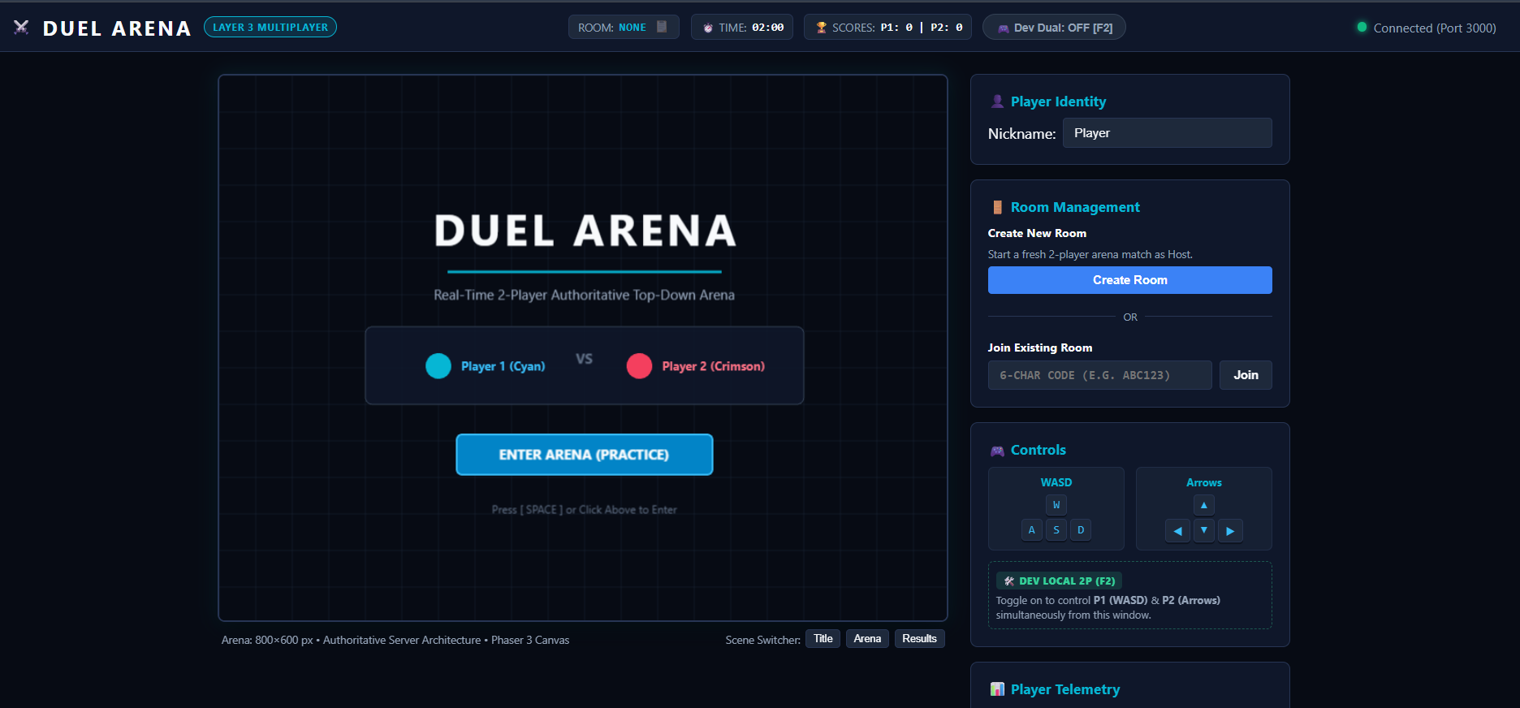
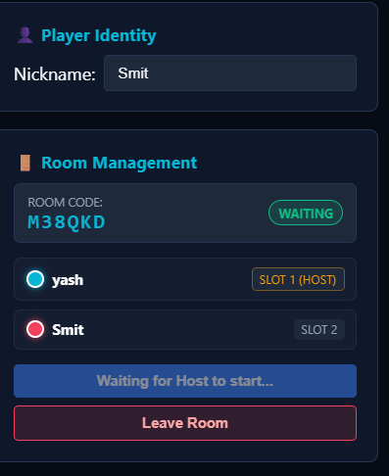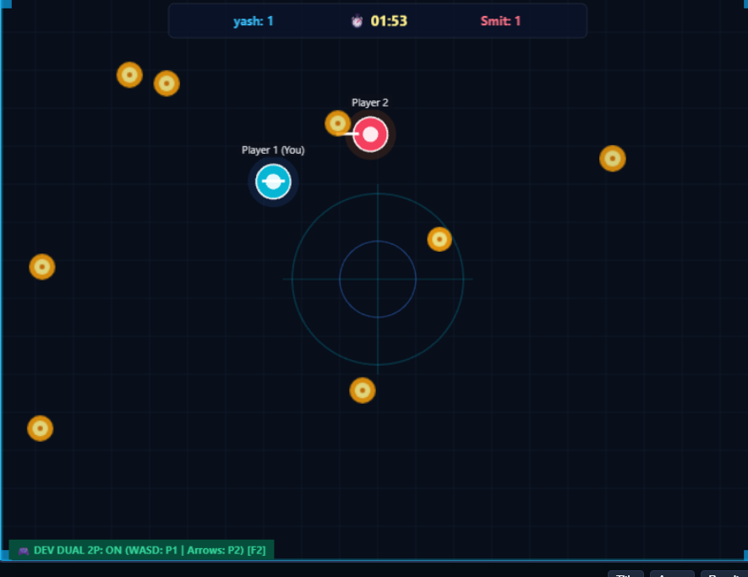

8. Verification and Security

8.1 Input Sanitization and Rate Limiting
- The server validates all input payloads at runtime (typeof === 'object', non-NaN checks).
- Cardinal directions are clamped strictly to {−1,0,1}\{-1, 0, 1\}{−1,0,1}.
- Input event frequencies exceeding 60 inputs per second per socket are dropped.

8.2 Boundary and Velocity Invariance
- Diagonal movement inputs (dx: 1, dy: 1) are normalized by dividing by 2≈1.414\sqrt{2} \approx 1.4142​≈1.414, guaranteeing players travel at an invariant 240 px/s regardless of direction.
- Player coordinates are clamped to arena boundaries, preventing players from leaving the visible canvas.

8.3 Concurrency and Deterministic Race Resolution
When multiple players enter the collection radius of the same coin during the same simulation tick:
- Contenders are sorted in ascending order of Euclidean distance to the coin center.
- If players are equidistant, the contender with the lower room slot index (slot 1 over slot 2) wins the tie-breaker.
- The coin is atomically deleted from server state during that tick. Subsequent collision evaluations in the same tick fail, ensuring points are awarded exactly once.

8.4 Production Security Isolation
The development-only dual-player testing mode is guarded on the server:
- If process.env.NODE_ENV === 'production', all 'dev-input' events are rejected.
- Sockets attempting 'dev-input' without membership in the active room are dropped.
- In production, each socket can only control its own assigned player entity.

9. Automated Testing & Results
The system includes 44 automated unit and integration tests implemented in Vitest. All 44 tests pass with zero failures:
Test Files 8 passed (8)
Tests 44 passed (44)
Start at 12:15:23
Duration ~3.0s

Test Suite Summary
Suite / Workspace | Tests | Key Behaviors Verified
packages/shared (constants.test.ts) | 3 | Arena dimensions (800×600800\times600800×600), player radius (18 px18\text{ px}18 px), tick rates (30 Hz30\text{ Hz}30 Hz), match duration (120 s120\text{ s}120 s).
packages/shared (math.test.ts) | 8 | Vector normalization, constant diagonal speed, zero vectors, arena bounds clamping.
apps/client (client.test.ts) | 4 | Snapshot interpolation buffer, monotonic sorting, buffer pruning, LERP calculations.
apps/server (health.test.ts) | 1 | GET /health endpoint status, uptime reporting, and active room count.
apps/server (roomManager.test.ts) | 10 | Room creation, code collisions, 2-player capacity enforcement, duplicate joins, host reassignment, disconnect cleanup.
apps/server (roomSocket.test.ts) | 1 | Socket.IO room creation, event dispatch, and connection negotiation.
apps/server (simulation.test.ts) | 10 | Authoritative movement, speed clamping, 20 Hz broadcast rate, single-window dual inputs, production rejection of dev-input, unauthorized socket rejection.
apps/server (gameRules.test.ts) | 7 | Exactly-once coin scoring, deterministic distance tie-breaking, slot tie-breaking, post-match input rejection, winner/draw calculation, rematch state reset, headless multi-client score synchronization.

10. Advantages and Limitations

10.1 Advantages
# | Benefit | Application to Duel Arena
1 | Authoritative Integrity | Clients cannot manipulate scores, coordinates, or timers; the server is the sole source of truth.
2 | Smooth Presentation (LERP) | A 100 ms interpolation buffer absorbs network packet jitter, delivering smooth 60 FPS motion from 20 Hz broadcasts.
3 | Deterministic Race Resolution | Explicit distance and slot ranking prevents duplicate coin collection anomalies during simultaneous collisions.
4 | Type Safety across Tiers | Shared contracts in @duel-arena/shared guarantee compile-time type verification across frontend and backend.
5 | Zero External Infrastructure | Operates entirely in Node.js server memory; requires no third-party database or cache to build, run, or test.
6 | Development Dual-Mode | Allows single-developer local testing from a single focused browser window without compromising production security.

10.2 Limitations
# | Limitation | Impact / Planned Mitigation
1 | Single-Server Process | State is held in-memory within a single Node.js process. Sockets cannot span multiple server instances without a distributed pub/sub adapter (e.g., Redis).
2 | Player Ceiling | Rooms are strictly limited to two players. Spectator modes and NNN-player arenas are not supported.
3 | No Persistent Storage | Match statistics and player profiles are not saved to disk; all state resets when the server process restarts.
4 | Unencrypted Transport in Dev | Default local development runs over unencrypted HTTP/WebSocket (ws://), requiring reverse-proxy TLS termination in production.

11. Conclusion
The Duel Arena project demonstrates the practical application of distributed computing principles to real-time interactive systems. By establishing an authoritative client-server model over Socket.IO and Phaser 3, the system eliminates client-side cheating and desynchronization.
The server maintains total ordering over simulation ticks, normalizes diagonal movement, clamps delta time against lag spikes, and deterministically resolves concurrent coin pickup race conditions. Clients sample user intent and render interpolated world snapshots, providing smooth visual output despite network jitter.
While the system is designed as an educational artifact with an in-memory single-node architecture, it demonstrates the core tenets of distributed software engineering: clear interface contracts, authoritative validation, concurrency arbitration, latency masking, and fault-tolerant session lifecycle handling.

References
- Coulouris, G., Dollimore, J., Kindberg, T., & Blair, G. (2011). Distributed Systems: Concepts and Design (5th ed.). Addison-Wesley.
- Tanenbaum, A. S., & van Steen, M. (2017). Distributed Systems: Principles and Paradigms (3rd ed.). CreateSpace Independent Publishing.
- Bernier, Y. W. (2001). Latency Compensating Methods in Client/Server In-game Protocol Design and Optimization. Valve Software.
- Socket.IO Documentation. Rooms, Namespaces, and Connection State Recovery. https://socket.io/docs/v4/
- Phaser 3 Game Framework. API Reference & Core Scene Lifecycles. https://photonstorm.github.io/phaser3-docs/
- Node.js Foundation. Node.js v22 LTS Documentation. https://nodejs.org/docs/latest-v22.x/api/http://localhost:5173/

